REFRENCE DOCUMENT FOR CUSTOMIZE ADDON REPORT

- <addon> This is starting tag for report XML.
- <info> Under this tag you need to enter your details.
- <authorname> Developer name or developer’s company name.
- <authoremail> Developer’s email address.
- <authorphone> Developer’s contact number.
- <type> You need to mention Report in this tag.
- <name> Name of report you want to show in Book Keeper.
- <description> Description of report you want to show in Book Keeper.
- <function> Your whole function for creating report will be under this tag.
- <input> Tag can be used multiple time to take input from users for report.
  - <varname> Use this tag to initialize variable like var1, var2, var3.. and so on
  - <msg> Message to show while taking input from user for each variable.
- <sql> You need to wright whole SQL query for report data in this tag.
- <result> In this tag SQL query result is used to create report view.
- <reportheading> Report heading is initialize in this tag.
  - <heading1> For line number 1 in report heading.
  - <heading2> For line number 2 in report heading.
  - <heading3> For line number 3 in report heading.
  - <heading4> For line number 4 in report heading.
  - <heading5> For line number 5 in report heading.
- <reportview> Data from SQL is shown here.
- <table> Table view for sql data is generated for report.
  - <thead> Set column name with its properties in same order as in SQL query
- align It aligns data in right or left or center in lower case only.
- type It sets column type as text or number or date in lower case only.
  - <tbody> It is default & compulsory tag with [DISPLAYHTMLREPORT] as value.
  - <tfoot> Sets column wise footer for data like [BLANK], [COUNT] or [SUM].
- <reportfooter> Any thing type in this tag will be display in report footer as it is.
- <exception> Contains the message for user in case of any exception occurrence.

NOTE: If you want to use “&” symbol as value in XML file use “&amp;”.

KEYWORDS
KEYWORDS for report header i.e. <reportheading> and report footer i.e. <reportfooter>
[STARTDATE] It will be picked from Reporting Period from the right panel of Book Keeper Windows Home Screen.
[ENDDATE] It will be picked from Reporting Period from the right panel of Book Keeper Windows Home Screen.
[COMPANYNAME] Developer company name like XYZ PVT. LTD
[COMPANYADDRESS] Developer company address like New Delhi
[COMPANYEMAIL] Developer company email like support@xyz.com
[COMPANYPHONE] Developer company phone like +91-9999xxxxxx
KEWORDS for report table body i.e. <tbody>
[DISPLAYHTMLREPORT] Compulsory and fixed variable as value for report table body in upper case only.
KEWORDS for report table footer i.e. <tfoot>
[SPACE] For blank column in table footer in upper case only
[COUNT] For showing total number of records in column of result data in upper case only
[SUM] For showing aggregate sum of records in column of result data in upper case only
Note: always use column type integer for [SUM]
KEYWORDS for SQL QUERY i.e. <sql>
[STARTDATE] It will be picked from Reporting Period from the right panel of Book Keeper Windows Home Screen.
[ENDDATE] It will be picked from Reporting Period from the right panel of Book Keeper Windows Home Screen.
Dynamic variable for SQL query:
Dynamic variable as input from user for SQL QUERY can be generated by putting into <INPUT> tag with variable name in <varname> tag like VAR1, VAR2, VAR3 with corresponding message to show while taking input for each variable from user in <msg> tag and use them like [VAR1], [VAR2], [VAR3].
Example: you want to create a report for particular customer and you need to ask that customer name from that user for which he want generate report. All you have to do is:
<input>
<varname>var1</varname>
<msg>Please enter customer name.</msg>
</input>
Using above code you will be asked for input with message “Please enter customer name.” when you open report in Book Keeper.
Then use this input from user in your SQL QUERY with keyword [VAR1]
SAMPLE XML FILE VIEW FOR REFRENCE
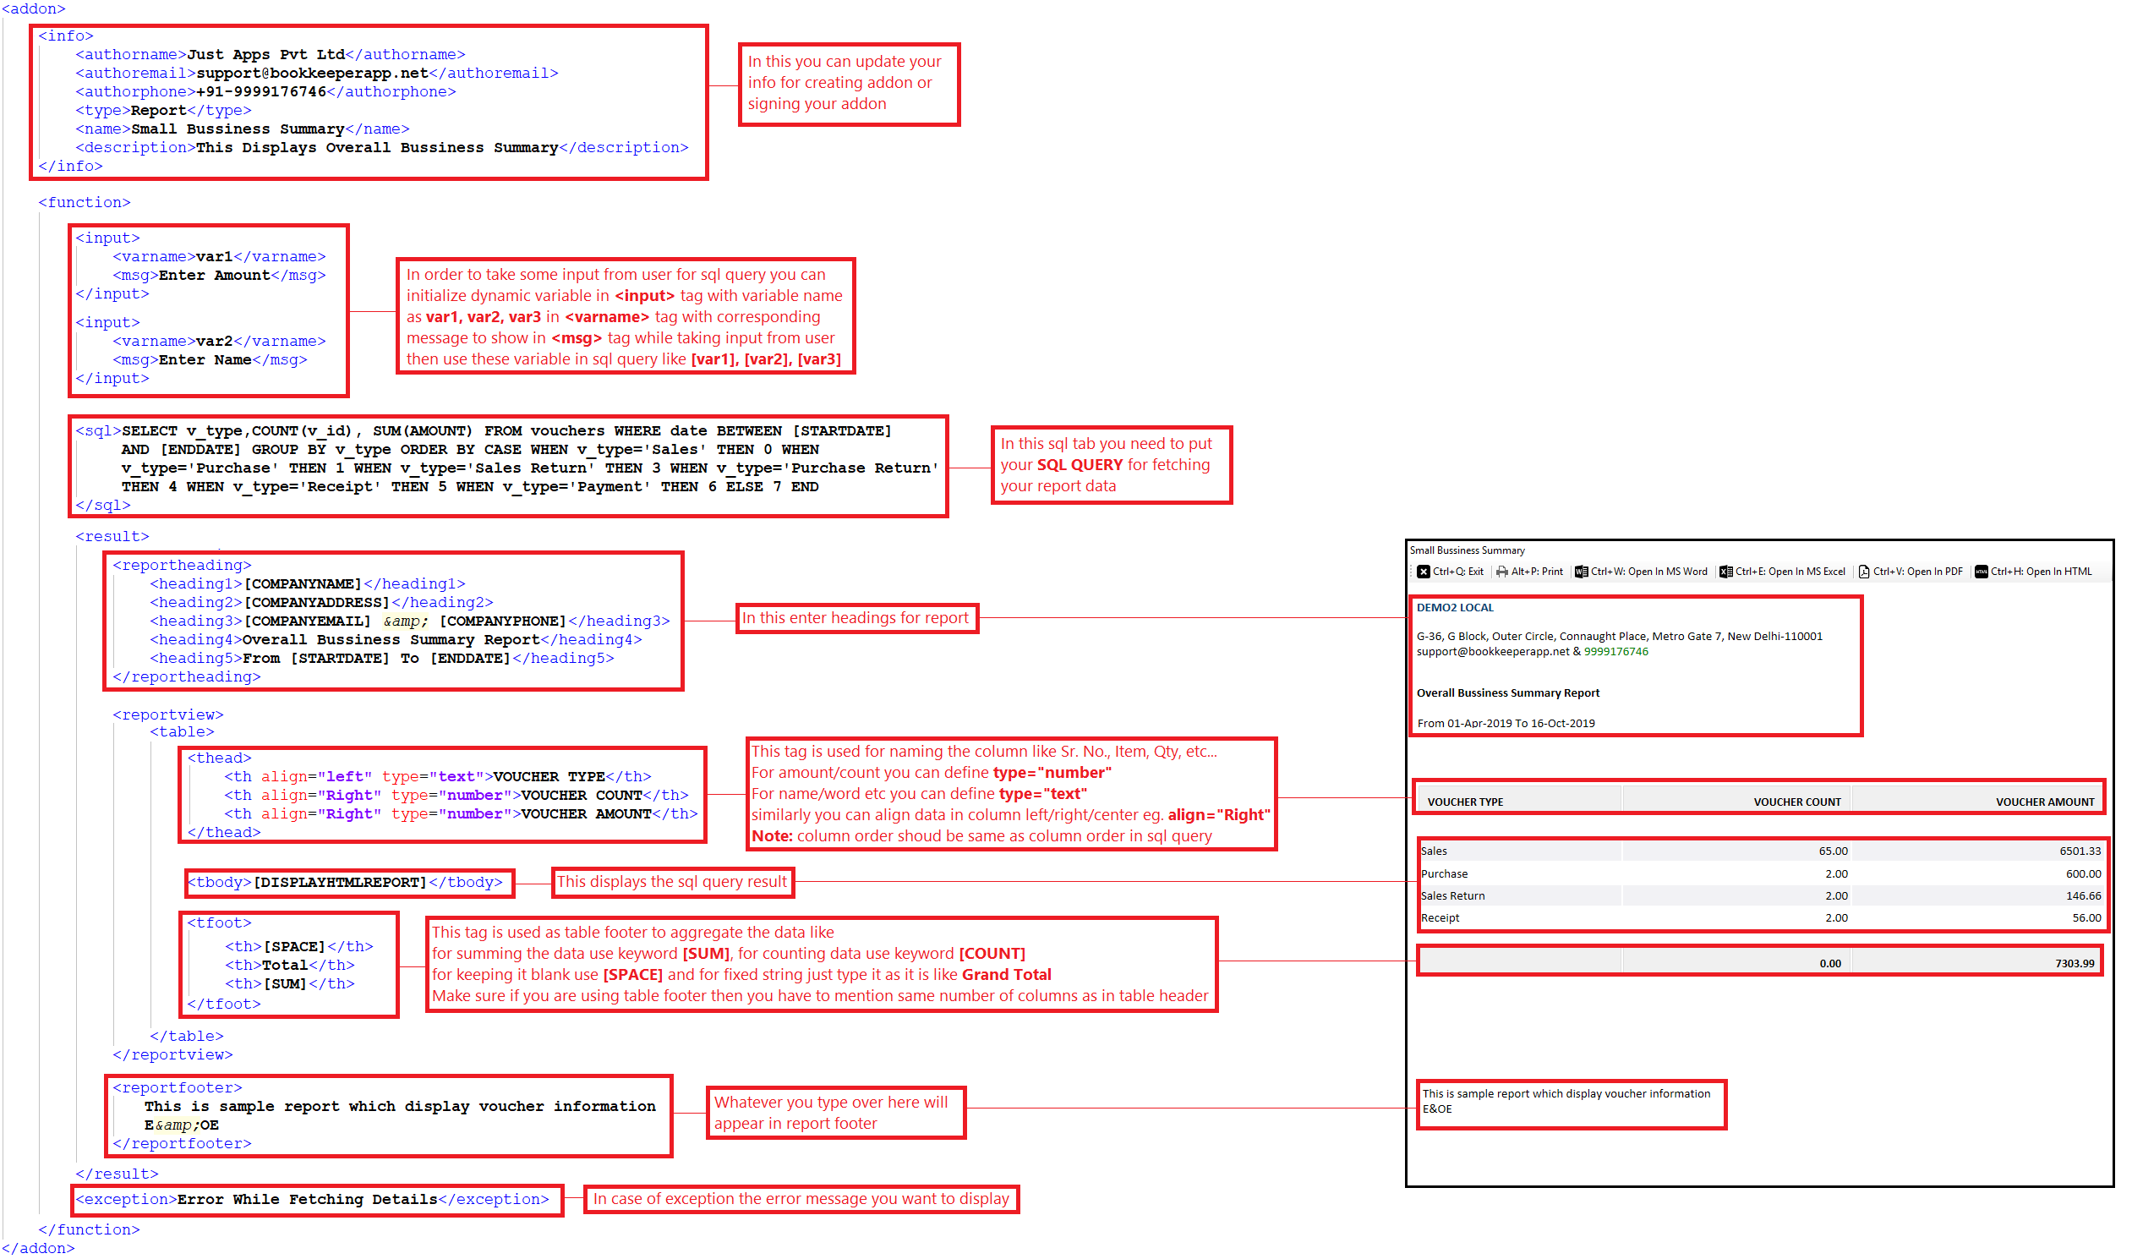

DATABASE STRUCTURE

Table Name: item_measure
Column Name | Description
item | Item Name
units_name | Unit Of Mesurement
item_desc | Item Description
remarks | Remarks
barcode | Barcode
sku | HSN/SKU Code
defaultsellingprice | Default Selling Price
defaultpurchaseprice | Default Purchase Price
defaultdiscountpercent | Default Discount Percentage
scheme_name | Default Tax Scheme
mrp | MRP
additional_cess | Addition Cess

Table Name: account_detail
Column Name | Description
aname | account Name
display_name | Display Name
a_type | Account Type
phone | Contact Number
email_id | Email Id
address | Address Line 1
address2 | Address Line 2
state | State
country | Country
pincode | Pincode
credit_period | Credit Period
tax_regn | GSTIN/Tax reristration number 1
date_created | Account Creation Date
tax_regn2 | Tax reristration number 2
tax_regn3 | Tax reristration number 3
op_bal | Opening Balance

Table Name: vouchers
Column Name | Description
v_id | Voucher unique Id
debit | Primary Debit Accout Name
credit | Primary Credit Accout Name
amount | Voucher Total Amount
date | Voucher Date
narration | Voucher Narration
v_type | Voucher Type
vch_no | Voucher Number
detail1 | Buyer Name
detail2 | Buyer Contact Number
detail3 | Buyer Address
detail4 | Sales Person
place_of_supply | State Name for INDIA ONLY
ecom_gstin | e-Way bill number
port_code | Port Code
shipping_no | Shipping Doc Number
shipping_date | Shipping Date
taxRegNo | Buyer GSTIN

Table Name: sales
Column Name | Description
s_v_id | Sales unique id
v_id | Vouchers unique Id
date | Sales Date
item | Item Name
sp_per_unit | Rate
units | Quantity
discount | Discount percent
scheme_name | Tax Scheme Name
desc | Discription
w_name | Warehouse Name
mrp | MRP
batch | Batch
brand | Brand
mfg_date | Manufacturing Date
exp_date | Expiry Date
size | Size
srno | Serial Number
weight | Weight
height | Height
count | Count

Table Name: purchases
Column Name | Description
p_v_id | Purchase unique Id
v_id | Vouchers unique Id
date | Purchase Date
item | Item Name
cost_per_unit | Rate
units | Quantity
discount | Discount percent
scheme_name | Tax Scheme Name
desc | Discription
w_name | Warehouse Name
mrp | MRP
batch | Batch
brand | Brand
mfg_date | Manufacturing Date
exp_date | Expiry Date
size | Size
srno | Serial Number
weight | Weight
height | Height
count | Count

